ENVIRONMENT DETECTION FOR BLIND PERSON

Project Code

Project Advisor
Prof. Muhammad Fahad

Project Manager
Dr. Muhammad Ilyas

Project Team
Muhammad Ali Raza Ansari (BSCS51F22S008) — Team Leader
Muhammad Abdullah Zammad (BSCS51F22S036) — Team Member
Muhammad Hassan Javed (BSCS51F22S040) — Team Member
Submission Date

Table of Contents
1. Abstract 3
2. Background and Justification 3
3. Project Methodology 3
4. Project Scope 3
5. High level Project Plan 3
6. References 3

Abstract
Portable assistive technology systems play a crucial role in enhancing the independence of individuals with disabilities, particularly those with visual impairments. Vision is a primary sense essential for perceiving and understanding the surrounding environment. Visually impaired individuals often face significant challenges in navigating dynamic outdoor environments where objects continuously change and move.
An effective object detection system can greatly assist these individuals by identifying and alerting them to nearby obstacles, thus improving their safety and mobility in daily life. This project aims to develop a simple, user-friendly, portable, cost-effective, and efficient object detection solution that uses a smartphone camera as an input device to detect obstacles in real time. The detected information is communicated to the user through auditory feedback via headphones.
The proposed system supports obstacle identification and avoidance in both indoor and outdoor settings, thereby enhancing the day-to-day activities and overall occupational performance of visually impaired persons. This technology offers valuable environmental awareness, empowering visually impaired users to navigate their surroundings more confidently and safely [2][3].

Background and Justification
Vision is a vital sense for human beings, crucial for perceiving and understanding the surrounding environment. However, a significant portion of the global population faces vision impairment or complete blindness, which severely limits their ability to interact safely and independently with their surroundings.
According to the World Health Organization (WHO) [1], approximately 2.2 billion people globally have some form of vision impairment, ranging from mild to severe.
Traditional aids such as white canes and human guides offer limited assistance — they primarily detect nearby obstacles but fail to provide comprehensive environmental awareness, especially in dynamic outdoor settings. These traditional methods also restrict independent mobility, raising safety concerns for visually impaired individuals.
There is a critical demand for affordable, user-friendly, and effective object detection systems that enable independent navigation by providing real-time awareness of surrounding objects.
Technological advances in computer vision, object detection, and image recognition provide new opportunities to address these challenges. Smartphone-based applications leveraging integrated cameras and powerful object detection algorithms like YOLOv3 (You Only Look Once version 3) can serve as effective assistive devices.
YOLOv3 offers the advantage of real-time object detection with high speed and accuracy, making it suitable for mobile environments. Existing efforts have explored various assistive systems, but many are costly, complex, or require additional hardware, limiting accessibility for many users [2][4].
This project aims to enhance prior work by developing an economical, efficient, and handheld object detection system that solely utilizes the smartphone’s built-in camera and audio outputs to detect and communicate the presence of obstacles. This approach eliminates the need for expensive dedicated devices, making the solution more accessible.
The system will identify objects in both indoor and outdoor environments and relay real-time audio information to users through speakers or headphones. By improving portability, cost-efficiency, and ease of use, this work intends to empower visually impaired individuals with greater independence and safety.

Project Methodology
The proposed system will use computer vision and audio feedback techniques to help visually impaired persons detect obstacles in real time. The smartphone camera will capture the surroundings, process the images using an object detection model (YOLOv3), and provide voice alerts through headphones.
- Image Acquisition:
The Smartphone’s built-in camera captures continuous real-time video frames as system input.
- Preprocessing:
Frames are enhanced using OpenCV (noise removal, resizing, and color adjustment) for better detection accuracy.
- Object Detection:
The YOLOv3 model (implemented with TensorFlow) identifies obstacles such as people, vehicles, or walls from each frame using the COCO dataset.
- Audio Feedback:
Detected object names are converted into speech using Text-to-Speech (TTS) engines like gTTS or pyttsx3, and played through headphones.
- User Interface:
A simple mobile app (built with Android Studio) allows users to start/stop detection and adjust settings.
- Testing & Evaluation:
The system will be tested in indoor and outdoor environments to evaluate detection accuracy, speed, and user satisfaction.

Project Scope

The proposed system focuses on providing real-time detection and audio notification of obstacles present in the surrounding environment to assist blind persons in navigating both indoor and outdoor settings safely.
Its primary functionality includes:
- Capturing environmental images using a smartphone camera
- Processing them with an object detection algorithm (YOLOv3) to identify potential obstacles
- Communicating this information audibly to the user via headphones
- Tell size of object small, medium, large
Functionality not includes:
- Not tell the distance between person and object
- No IoT device uses

High level Project Plan

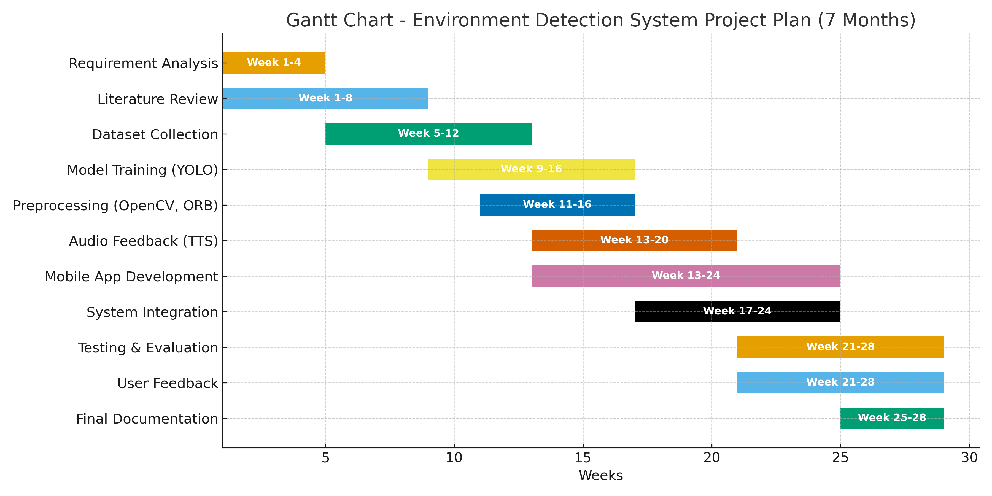

References
1. WHO: https://www.who.int/publications/i/item/world-report-on-vision

2 . Khairnar, D. P., Karad, R. B., Kapse, A., Kale, G., & Jadhav, P. (2020, 7 10). ieeexplore.com. Retrieved 10 4, 2025, from ieeexplore: https://ieeexplore.ieee.org/document/9137791
Team, W. (2019, 10 8). www.who.com. Retrieved 10 4, 2025, from

3. Dr. K. Nagi Reddy, K. S. (2023). Real Time Object Detection with Audio Feedback using Yolo_v3. International Journal of Trend in Scientific Research and Development (IJTSRD) ,

4. Farhadi, J. R. (n.d.). YOLOv3: An Incremental Improvement. YOLOv3: An Incremental Improvement , 6.

